CSA1103 00AD-LAB P.Gayathri(192321169)

Question 10: Hotel Reservation System –Scenario: A hotel reservation application manages customers, rooms, reservations, payments, and staff. Customers search available rooms based on dates and room categories. Receptionists confirm bookings after payment verification. Housekeeping updates room availability after cleaning. Managers monitor occupancy reports and revenue statistics. Customers receive booking confirmation messages instantly. Rooms can be reserved, occupied, or under maintenance. Staff information is maintained separately. The management wants to view the runtime instances of objects involved in a booking
USE CASE DIAGRAM:
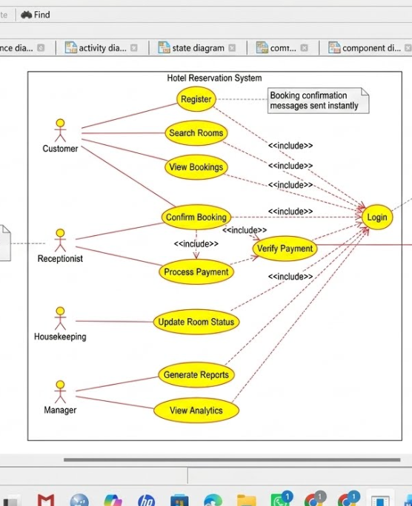
CLASS DIAGRAM:
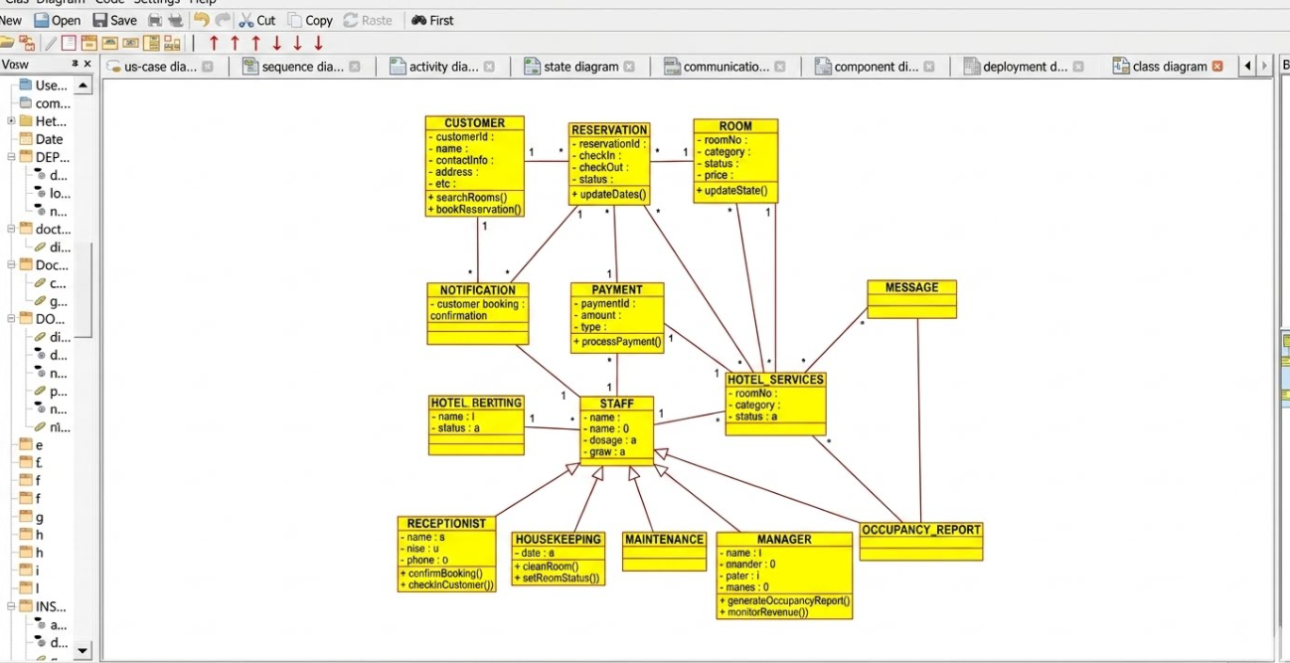
ACTIVITY DIAGRAM:
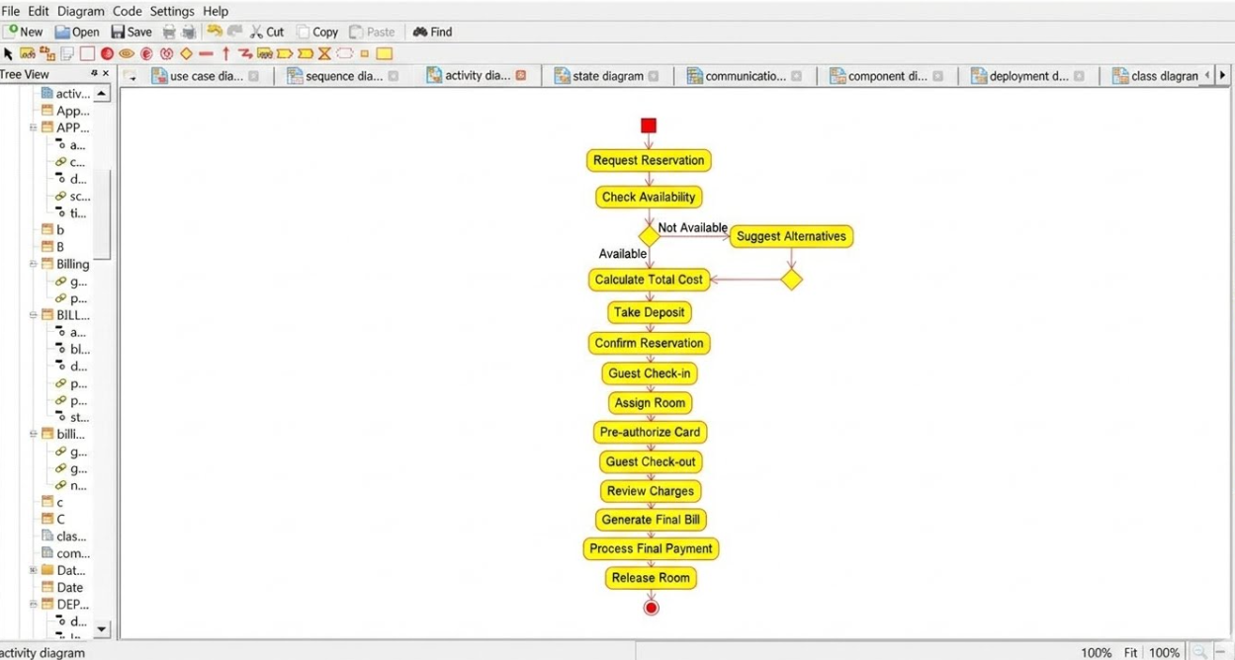
DEPLOYMENT DIAGRAM:
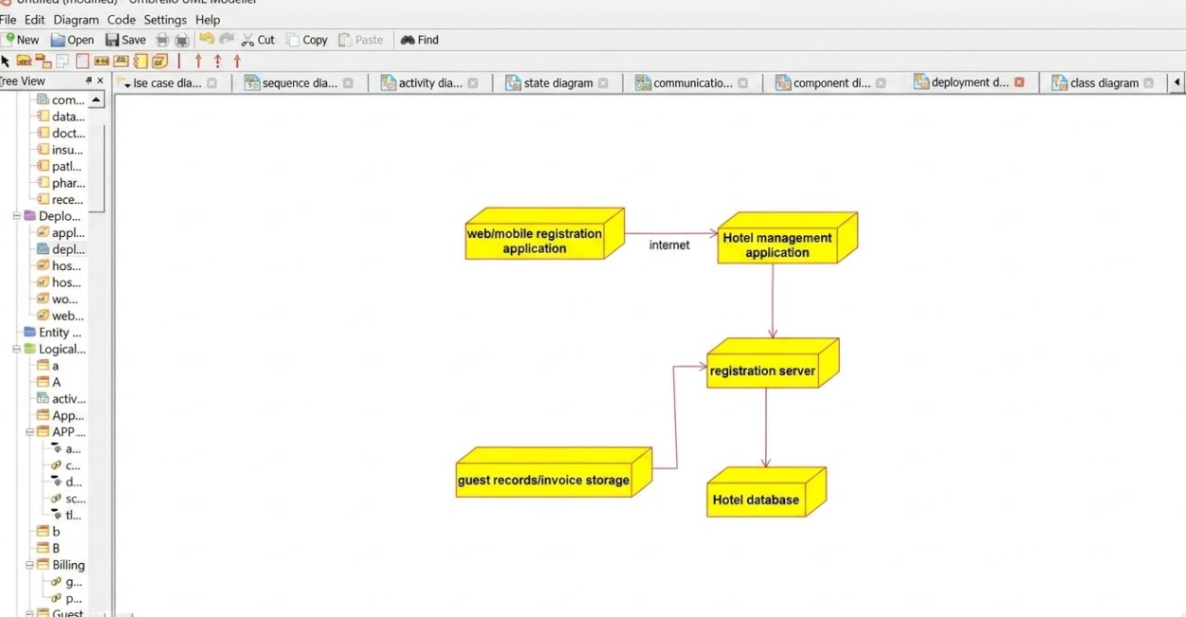

SEQUENCE DIAGRAM:
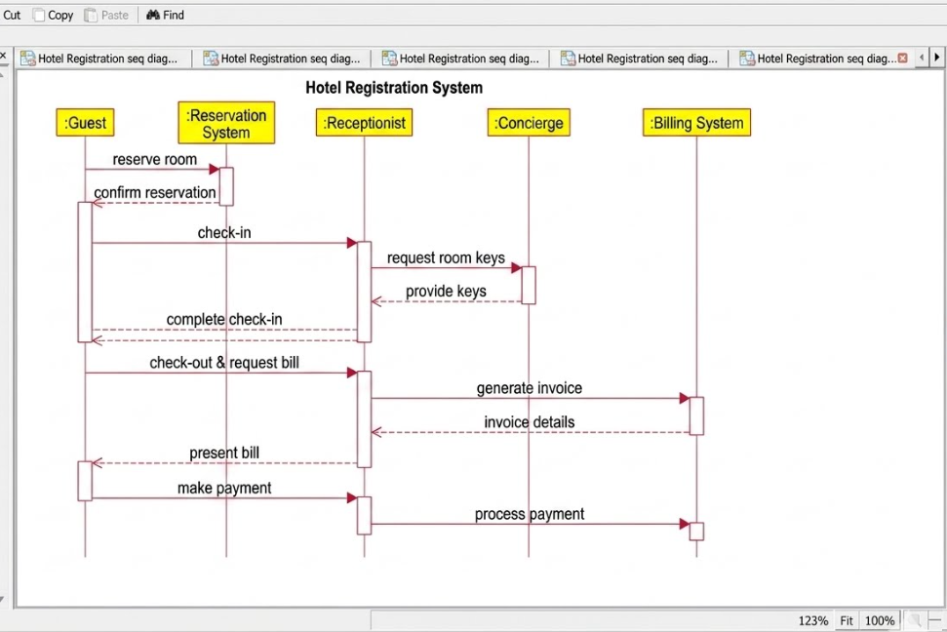
STATE MACHINE DIAGRAM:
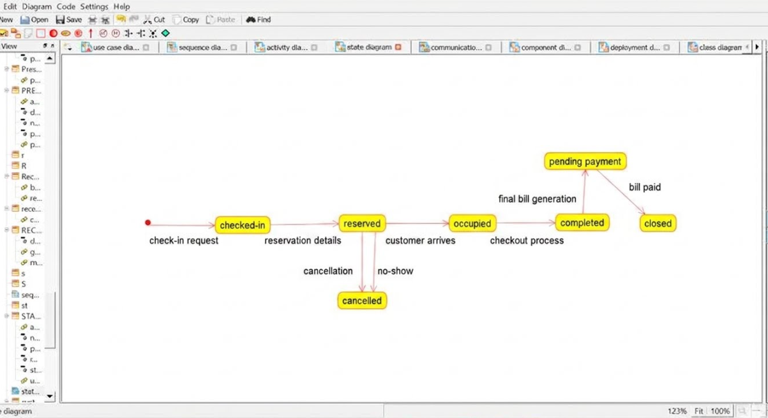
COMPONENT DIAGRAM:
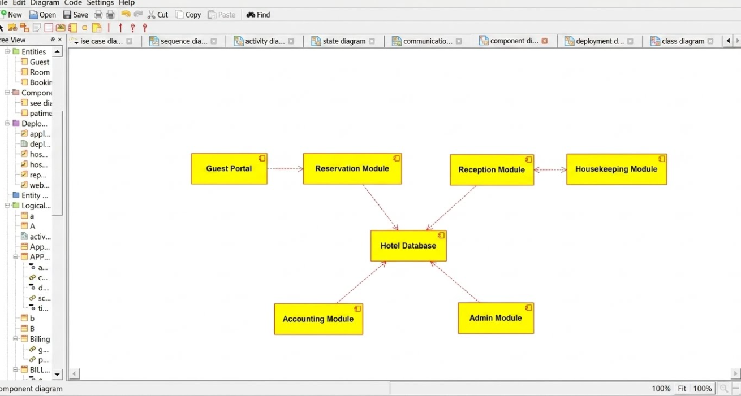
COMMUNICATION DIAGRAM:
